1. Time Conversion

Code:-

#include <bits/stdc++.h>

using namespace std;

/*

* Complete the 'timeConversion' function below.

*

* The function is expected to return a STRING.

* The function accepts STRING s as parameter.

*/

string timeConversion(string s) {

int h = stoi(s.substr(0, 2)); // Extract hours

string minute = s.substr(3, 2); // Extract minutes

string second = s.substr(6, 2); // Extract seconds

string am_pm = s.substr(8, 2); // Extract AM/PM

if (am_pm == "PM" && h != 12) {

h += 12;

} else if (am_pm == "AM" && h == 12) {

h = 0;

}

string hour;

int unit = h % 10;

h = h / 10;

int decimals = h % 10;

if (decimals == 0) {

hour = "0" + to_string(unit);

}

else {

hour = to_string(decimals) + to_string(unit);

}

string Time_24 = hour + ":" + minute + ":" + second;

return Time_24;

}

int main()

{

ofstream fout(getenv("OUTPUT_PATH"));

string s;

getline(cin, s);

string result = timeConversion(s);

fout << result << "\n";

fout.close();

return 0;

}

Output :-



1. Birthday Cake Candles

#include <bits/stdc++.h>

using namespace std;

string ltrim(const string &);

string rtrim(const string &);

vector<string> split(const string &);

/*

* Complete the 'birthdayCakeCandles' function below.

*

* The function is expected to return an INTEGER.

* The function accepts INTEGER_ARRAY candles as parameter.

*/

int birthdayCakeCandles(vector<int> candles) {

int max_number = candles[0];

int max_count = 0;

for(int i = 0; i < candles.size(); i++) {

if(candles[i] == max_number) {

max_count++;

} else if(candles[i] > max_number) {

max_number = candles[i];

max_count = 1;

}

}

return max_count;

}

int main()

{

ofstream fout(getenv("OUTPUT_PATH"));

string candles_count_temp;

getline(cin, candles_count_temp);

int candles_count = stoi(ltrim(rtrim(candles_count_temp)));

string candles_temp_temp;

getline(cin, candles_temp_temp);

vector<string> candles_temp = split(rtrim(candles_temp_temp));

vector<int> candles(candles_count);

for (int i = 0; i < candles_count; i++) {

int candles_item = stoi(candles_temp[i]);

candles[i] = candles_item;

}

int result = birthdayCakeCandles(candles);

fout << result << "\n";

fout.close();

return 0;

}

string ltrim(const string &str) {

string s(str);

s.erase(

s.begin(),

find_if(s.begin(), s.end(), not1(ptr_fun<int, int>(isspace)))

);

return s;

}

string rtrim(const string &str) {

string s(str);

s.erase(

find_if(s.rbegin(), s.rend(), not1(ptr_fun<int, int>(isspace))).base(),

s.end()

);

return s;

}

vector<string> split(const string &str) {

vector<string> tokens;

string::size_type start = 0;

string::size_type end = 0;

while ((end = str.find(" ", start)) != string::npos) {

tokens.push_back(str.substr(start, end - start));

start = end + 1;

}

tokens.push_back(str.substr(start));

return tokens;

}

Output :[-



3. Compare the Triplets

Code:-

#include <bits/stdc++.h>

using namespace std;

string ltrim(const string &);

string rtrim(const string &);

vector<string> split(const string &);

/*

* Complete the 'compareTriplets' function below.

*

* The function is expected to return an INTEGER_ARRAY.

* The function accepts following parameters:

* 1. INTEGER_ARRAY a

* 2. INTEGER_ARRAY b

*/

vector<int> compareTriplets(vector<int> a, vector<int> b) {

vector<int> Answer(2,0);

for(int i = 0 ; i < a.size() ; i++) {

if(a[i] > b[i]) {

Answer[0]++;

}

else if(a[i] < b[i]) {

Answer[1]++;

}

}

return Answer;

}

int main()

{

ofstream fout(getenv("OUTPUT_PATH"));

string a_temp_temp;

getline(cin, a_temp_temp);

vector<string> a_temp = split(rtrim(a_temp_temp));

vector<int> a(3);

for (int i = 0; i < 3; i++) {

int a_item = stoi(a_temp[i]);

a[i] = a_item;

}

string b_temp_temp;

getline(cin, b_temp_temp);

vector<string> b_temp = split(rtrim(b_temp_temp));

vector<int> b(3);

for (int i = 0; i < 3; i++) {

int b_item = stoi(b_temp[i]);

b[i] = b_item;

}

vector<int> result = compareTriplets(a, b);

for (size_t i = 0; i < result.size(); i++) {

fout << result[i];

if (i != result.size() - 1) {

fout << " ";

}

}

fout << "\n";

fout.close();

return 0;

}

string ltrim(const string &str) {

string s(str);

s.erase(

s.begin(),

find_if(s.begin(), s.end(), not1(ptr_fun<int, int>(isspace)))

);

return s;

}

string rtrim(const string &str) {

string s(str);

s.erase(

find_if(s.rbegin(), s.rend(), not1(ptr_fun<int, int>(isspace))).base(),

s.end()

);

return s;

}

vector<string> split(const string &str) {

vector<string> tokens;

string::size_type start = 0;

string::size_type end = 0;

while ((end = str.find(" ", start)) != string::npos) {

tokens.push_back(str.substr(start, end - start));

start = end + 1;

}

tokens.push_back(str.substr(start));

return tokens;

}

Output ➖



4. Diagonal Difference

Code :-

#include <bits/stdc++.h>

using namespace std;

string ltrim(const string &);

string rtrim(const string &);

vector<string> split(const string &);

/*

* Complete the 'diagonalDifference' function below.

*

* The function is expected to return an INTEGER.

* The function accepts 2D_INTEGER_ARRAY arr as parameter.

*/

int diagonalDifference(vector<vector<int>> arr) {

int primary_diagonal = 0;

int not_primary_diagonal = 0;

int matrix_size = arr.size();

for(int i = 0;i<matrix_size;i++){

primary_diagonal+=arr[i][i];

not_primary_diagonal+=arr[matrix_size-i-1][i];

}

return abs(primary_diagonal-not_primary_diagonal);

}

int main()

{

ofstream fout(getenv("OUTPUT_PATH"));

string n_temp;

getline(cin, n_temp);

int n = stoi(ltrim(rtrim(n_temp)));

vector<vector<int>> arr(n);

for (int i = 0; i < n; i++) {

arr[i].resize(n);

string arr_row_temp_temp;

getline(cin, arr_row_temp_temp);

vector<string> arr_row_temp = split(rtrim(arr_row_temp_temp));

for (int j = 0; j < n; j++) {

int arr_row_item = stoi(arr_row_temp[j]);

arr[i][j] = arr_row_item;

}

}

int result = diagonalDifference(arr);

fout << result << "\n";

fout.close();

return 0;

}

string ltrim(const string &str) {

string s(str);

s.erase(

s.begin(),

find_if(s.begin(), s.end(), not1(ptr_fun<int, int>(isspace)))

);

return s;

}

string rtrim(const string &str) {

string s(str);

s.erase(

find_if(s.rbegin(), s.rend(), not1(ptr_fun<int, int>(isspace))).base(),

s.end()

);

return s;

}

vector<string> split(const string &str) {

vector<string> tokens;

string::size_type start = 0;

string::size_type end = 0;

while ((end = str.find(" ", start)) != string::npos) {

tokens.push_back(str.substr(start, end - start));

start = end + 1;

}

tokens.push_back(str.substr(start));

return tokens;

}

Output :-



5. Mini-Max Sum

Code :-

#include <bits/stdc++.h>

using namespace std;

string ltrim(const string &);

string rtrim(const string &);

vector<string> split(const string &);

/*

* Complete the 'miniMaxSum' function below.

*

* The function accepts INTEGER_ARRAY arr as parameter.

*/

void miniMaxSum(vector<int> arr) {

int_fast64_t min = 0 ;

int_fast64_t max = 0 ;

sort(arr.begin() , arr.end());

for(int i = 0 ; i <= 3 ; i++) {

min += arr[i] ;

max += arr[i+1] ;

}

cout << min << " " << max << endl;

}

int main()

{

string arr_temp_temp;

getline(cin, arr_temp_temp);

vector<string> arr_temp = split(rtrim(arr_temp_temp));

vector<int> arr(5);

for (int i = 0; i < 5; i++) {

int arr_item = stoi(arr_temp[i]);

arr[i] = arr_item;

}

miniMaxSum(arr);

return 0;

}

string ltrim(const string &str) {

string s(str);

s.erase(

s.begin(),

find_if(s.begin(), s.end(), not1(ptr_fun<int, int>(isspace)))

);

return s;

}

string rtrim(const string &str) {

string s(str);

s.erase(

find_if(s.rbegin(), s.rend(), not1(ptr_fun<int, int>(isspace))).base(),

s.end()

);

return s;

}

vector<string> split(const string &str) {

vector<string> tokens;

string::size_type start = 0;

string::size_type end = 0;

while ((end = str.find(" ", start)) != string::npos) {

tokens.push_back(str.substr(start, end - start));

start = end + 1;

}

tokens.push_back(str.substr(start));

return tokens;

}

Output :-



6. Plus Minus

Code :-

#include <bits/stdc++.h>

using namespace std;

string ltrim(const string &);

string rtrim(const string &);

vector<string> split(const string &);

/*

* Complete the 'plusMinus' function below.

*

* The function accepts INTEGER_ARRAY arr as parameter.

*/

void plusMinus(vector<int> arr) {

double sp, sn, sz, pa = 1.0 / arr.size();

sp = sn = sz = 0;

for(int i = 0; i < arr.size(); i++){

if(arr[i] > 0) sp+= pa;

else if(arr[i]<0) sn+= pa;

else sz+= pa;

}

cout << setprecision(6) << fixed;

cout << sp <<endl;

cout << sn <<endl;

cout << sz <<endl;

}

int main()

{

string n_temp;

getline(cin, n_temp);

int n = stoi(ltrim(rtrim(n_temp)));

string arr_temp_temp;

getline(cin, arr_temp_temp);

vector<string> arr_temp = split(rtrim(arr_temp_temp));

vector<int> arr(n);

for (int i = 0; i < n; i++) {

int arr_item = stoi(arr_temp[i]);

arr[i] = arr_item;

}

plusMinus(arr);

return 0;

}

string ltrim(const string &str) {

string s(str);

s.erase(

s.begin(),

find_if(s.begin(), s.end(), not1(ptr_fun<int, int>(isspace)))

);

return s;

}

string rtrim(const string &str) {

string s(str);

s.erase(

find_if(s.rbegin(), s.rend(), not1(ptr_fun<int, int>(isspace))).base(),

s.end()

);

return s;

}

vector<string> split(const string &str) {

vector<string> tokens;

string::size_type start = 0;

string::size_type end = 0;

while ((end = str.find(" ", start)) != string::npos) {

tokens.push_back(str.substr(start, end - start));

start = end + 1;

}

tokens.push_back(str.substr(start));

return tokens;

}

Output :-



7. Staircase

#include <bits/stdc++.h>

using namespace std;

string ltrim(const string &);

string rtrim(const string &);

/*

* Complete the 'staircase' function below.

*

* The function accepts INTEGER n as parameter.

*/

void staircase(int n) {

for(int i = 1 ; i <= n; i++) {

for(int j = 1 ; j <= n - i ; j++) {

cout << " " ;

}

for(int j =1 ; j <= i ; j++) {

cout << "#" ;

}

cout << endl;

}

}

int main()

{

string n_temp;

getline(cin, n_temp);

int n = stoi(ltrim(rtrim(n_temp)));

staircase(n);

return 0;

}

string ltrim(const string &str) {

string s(str);

s.erase(

s.begin(),

find_if(s.begin(), s.end(), not1(ptr_fun<int, int>(isspace)))

);

return s;

}

string rtrim(const string &str) {

string s(str);

s.erase(

find_if(s.rbegin(), s.rend(), not1(ptr_fun<int, int>(isspace))).base(),

s.end()

);

return s;

}

Output :-



8. Migratory Bird

#include <bits/stdc++.h>

using namespace std;

string ltrim(const string &);

string rtrim(const string &);

vector<string> split(const string &);

/*

* Complete the 'migratoryBirds' function below.

*

* The function is expected to return an INTEGER.

* The function accepts INTEGER_ARRAY arr as parameter.

*/

int migratoryBirds(vector<int> arr) {

map<int, int> hello;

int max_element = 0;

for(int i:arr){

hello[i]++;

max_element = max(max_element,hello[i]);

}

int min_element = INT_MAX;

for(auto &current:hello){

if(current.second == max_element){

min_element =

min(min_element,current.first);

}

}

return min_element;

}

int main()

{

ofstream fout(getenv("OUTPUT_PATH"));

string arr_count_temp;

getline(cin, arr_count_temp);

int arr_count = stoi(ltrim(rtrim(arr_count_temp)));

string arr_temp_temp;

getline(cin, arr_temp_temp);

vector<string> arr_temp = split(rtrim(arr_temp_temp));

vector<int> arr(arr_count);

for (int i = 0; i < arr_count; i++) {

int arr_item = stoi(arr_temp[i]);

arr[i] = arr_item;

}

int result = migratoryBirds(arr);

fout << result << "\n";

fout.close();

return 0;

}

string ltrim(const string &str) {

string s(str);

s.erase(

s.begin(),

find_if(s.begin(), s.end(), not1(ptr_fun<int, int>(isspace)))

);

return s;

}

string rtrim(const string &str) {

string s(str);

s.erase(

find_if(s.rbegin(), s.rend(), not1(ptr_fun<int, int>(isspace))).base(),

s.end()

);

return s;

}

vector<string> split(const string &str) {

vector<string> tokens;

string::size_type start = 0;

string::size_type end = 0;

while ((end = str.find(" ", start)) != string::npos) {

tokens.push_back(str.substr(start, end - start));

start = end + 1;

}

tokens.push_back(str.substr(start));

return tokens;

}

Output :-

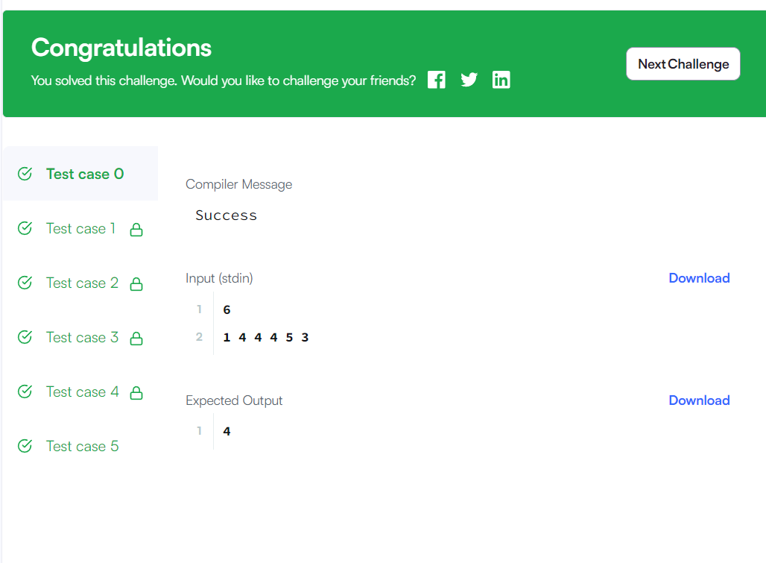

9. Minimum Distances

#include <bits/stdc++.h>

using namespace std;

string ltrim(const string &);

string rtrim(const string &);

vector<string> split(const string &);

/*

* Complete the 'minimumDistances' function below.

*

* The function is expected to return an INTEGER.

* The function accepts INTEGER_ARRAY a as parameter.

*/

int minimumDistances(vector<int> a) {

unordered_map<int,int> counter;

int min_distance = 10000 ;

for(int i = 0 ; i < a.size() ; i++) {

if(counter[a[i]]) {

min_distance = min(min_distance , abs(i + 1 - counter[a[i]]));

}

else {

counter[a[i]] = i + 1;

}

}

return min_distance == 10000 ? -1 : min_distance ;

}

int main()

{

ofstream fout(getenv("OUTPUT_PATH"));

string n_temp;

getline(cin, n_temp);

int n = stoi(ltrim(rtrim(n_temp)));

string a_temp_temp;

getline(cin, a_temp_temp);

vector<string> a_temp = split(rtrim(a_temp_temp));

vector<int> a(n);

for (int i = 0; i < n; i++) {

int a_item = stoi(a_temp[i]);

a[i] = a_item;

}

int result = minimumDistances(a);

fout << result << "\n";

fout.close();

return 0;

}

string ltrim(const string &str) {

string s(str);

s.erase(

s.begin(),

find_if(s.begin(), s.end(), not1(ptr_fun<int, int>(isspace)))

);

return s;

}

string rtrim(const string &str) {

string s(str);

s.erase(

find_if(s.rbegin(), s.rend(), not1(ptr_fun<int, int>(isspace))).base(),

s.end()

);

return s;

}

vector<string> split(const string &str) {

vector<string> tokens;

string::size_type start = 0;

string::size_type end = 0;

while ((end = str.find(" ", start)) != string::npos) {

tokens.push_back(str.substr(start, end - start));

start = end + 1;

}

tokens.push_back(str.substr(start));

return tokens;

}

Output :-

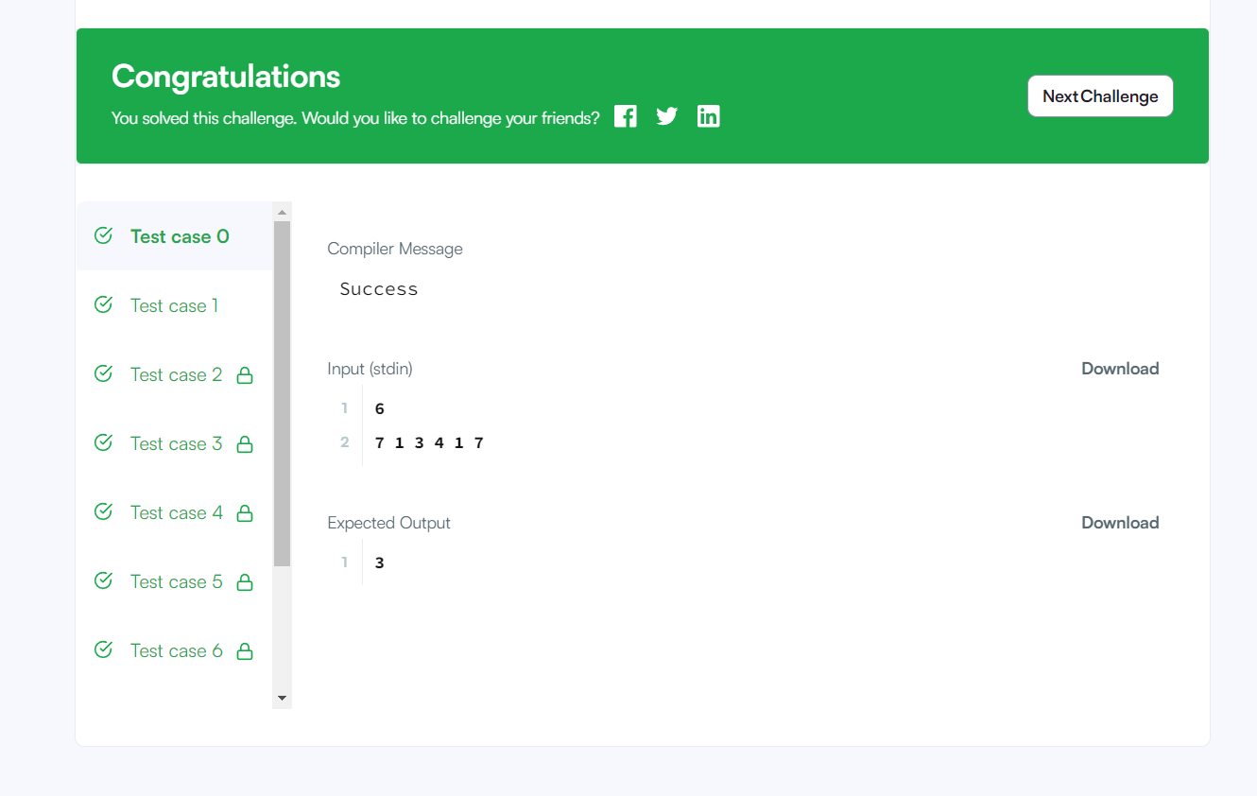

10 Sequence Equation

Code :-

#include <bits/stdc++.h>

using namespace std;

string ltrim(const string &);

string rtrim(const string &);

vector<string> split(const string &);

/*

* Complete the 'permutationEquation' function below.

*

* The function is expected to return an INTEGER_ARRAY.

* The function accepts INTEGER_ARRAY p as parameter.

*/

vector<int> permutationEquation(vector<int> p) {

vector<int> indexes(p.size() + 1), result;

for(int i = 1; i <= p.size(); i++) indexes[p[i-1]] = i;

for(int i = 1; i <= p.size(); i++) result.push_back(indexes[indexes[i]]);

return result;

}

int main()

{

ofstream fout(getenv("OUTPUT_PATH"));

string n_temp;

getline(cin, n_temp);

int n = stoi(ltrim(rtrim(n_temp)));

string p_temp_temp;

getline(cin, p_temp_temp);

vector<string> p_temp = split(rtrim(p_temp_temp));

vector<int> p(n);

for (int i = 0; i < n; i++) {

int p_item = stoi(p_temp[i]);

p[i] = p_item;

}

vector<int> result = permutationEquation(p);

for (size_t i = 0; i < result.size(); i++) {

fout << result[i];

if (i != result.size() - 1) {

fout << "\n";

}

}

fout << "\n";

fout.close();

return 0;

}

string ltrim(const string &str) {

string s(str);

s.erase(

s.begin(),

find_if(s.begin(), s.end(), not1(ptr_fun<int, int>(isspace)))

);

return s;

}

string rtrim(const string &str) {

string s(str);

s.erase(

find_if(s.rbegin(), s.rend(), not1(ptr_fun<int, int>(isspace))).base(),

s.end()

);

return s;

}

vector<string> split(const string &str) {

vector<string> tokens;

string::size_type start = 0;

string::size_type end = 0;

while ((end = str.find(" ", start)) != string::npos) {

tokens.push_back(str.substr(start, end - start));

start = end + 1;

}

tokens.push_back(str.substr(start));

return tokens;

}

Output :-



11. **Picking Numbers**

**Code :-**

**#include <bits/stdc++.h>**

**using namespace std;**

**string ltrim(const string &);**

**string rtrim(const string &);**

**vector<string> split(const string &);**

**/\***

**\* Complete the 'pickingNumbers' function below.**

**\***

**\* The function is expected to return an INTEGER.**

**\* The function accepts INTEGER_ARRAY a as parameter.**

**\*/**

**int pickingNumbers(vector<int> a) {**

**int count = 0 ;**

**int max_count = INT_MIN;**

**int negative_count = 0;**

**int positive_count = 0;**

**for(int j = 0;j<a.size()-1;j++){**

**for(int i = j;i<a.size();i++){**

**if(abs(a[j]-a[i])<2){**

**if((a[j]-a[i])>0){**

**positive_count++;**

**}**

**if((a[j]-a[i])<0){**

**negative_count++;**

**}**

**if((a[j]-a[i])==0){**

**positive_count++;**

**negative_count++;**

**}**

**}**

**}**

**count = max(positive_count,negative_count);**

**positive_count = 0;**

**negative_count = 0;**

**max_count = max(max_count,count);**

**count = 0;**

**}**

**if(count == 0){**

**count = 1;**

**}**

**return max_count;**

**}**

**int main()**

**{**

**ofstream fout(getenv("OUTPUT_PATH"));**

**string n_temp;**

**getline(cin, n_temp);**

**int n = stoi(ltrim(rtrim(n_temp)));**

**string a_temp_temp;**

**getline(cin, a_temp_temp);**

**vector<string> a_temp = split(rtrim(a_temp_temp));**

**vector<int> a(n);**

**for (int i = 0; i < n; i++) {**

**int a_item = stoi(a_temp[i]);**

**a[i] = a_item;**

**}**

**int result = pickingNumbers(a);**

**fout << result << "\n";**

**fout.close();**

**return 0;**

**}**

**string ltrim(const string &str) {**

**string s(str);**

**s.erase(**

**s.begin(),**

**find_if(s.begin(), s.end(), not1(ptr_fun<int, int>(isspace)))**

**);**

**return s;**

**}**

**string rtrim(const string &str) {**

**string s(str);**

**s.erase(**

**find_if(s.rbegin(), s.rend(), not1(ptr_fun<int, int>(isspace))).base(),**

**s.end()**

**);**

**return s;**

**}**

**vector<string> split(const string &str) {**

**vector<string> tokens;**

**string::size_type start = 0;**

**string::size_type end = 0;**

**while ((end = str.find(" ", start)) != string::npos) {**

**tokens.push_back(str.substr(start, end - start));**

**start = end + 1;**

**}**

**tokens.push_back(str.substr(start));**

**return tokens;**

**}**

**Output :-**

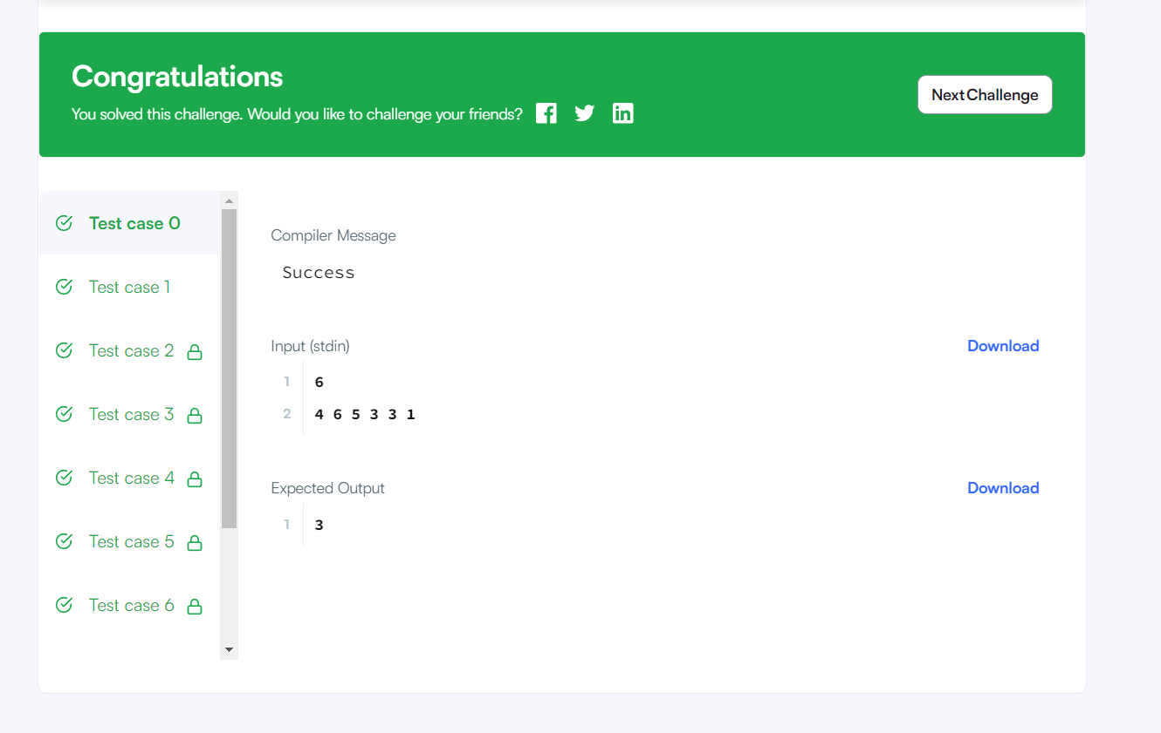

13 .Repeated String

#include <bits/stdc++.h>

using namespace std;

string ltrim(const string &);

string rtrim(const string &);

/*

* Complete the 'repeatedString' function below.

*

* The function is expected to return a LONG_INTEGER.

* The function accepts following parameters:

* 1. STRING s

* 2. LONG_INTEGER n

*/

long repeatedString(string s, long n) {

long ans = 0 ;

int noofA = 0;

for(char& chr : s) {

if(chr == 'a') {

noofA++;

}

}

long full = n / s.size() ;

long partial_r = n % s.size() ;

ans = noofA * full ;

for(int i = 0 ; i < partial_r ; i++) {

if(s[i] == 'a') {

ans++;

}

}

return ans;

}

int main()

{

ofstream fout(getenv("OUTPUT_PATH"));

string s;

getline(cin, s);

string n_temp;

getline(cin, n_temp);

long n = stol(ltrim(rtrim(n_temp)));

long result = repeatedString(s, n);

fout << result << "\n";

fout.close();

return 0;

}

string ltrim(const string &str) {

string s(str);

s.erase(

s.begin(),

find_if(s.begin(), s.end(), not1(ptr_fun<int, int>(isspace)))

);

return s;

}

string rtrim(const string &str) {

string s(str);

s.erase(

find_if(s.rbegin(), s.rend(), not1(ptr_fun<int, int>(isspace))).base(),

s.end()

);

return s;

}

Output :-



14. Save the Prisoner

Code :-

#include <bits/stdc++.h>

using namespace std;

string ltrim(const string &);

string rtrim(const string &);

vector<string> split(const string &);

/*

* Complete the 'saveThePrisoner' function below.

*

* The function is expected to return an INTEGER.

* The function accepts following parameters:

* 1. INTEGER n

* 2. INTEGER m

* 3. INTEGER s

*/

int saveThePrisoner(int n, int m, int s) {

return (s+m-1) %n == 0 ? n : (s+m-1)%n;

}

int main()

{

ofstream fout(getenv("OUTPUT_PATH"));

string t_temp;

getline(cin, t_temp);

int t = stoi(ltrim(rtrim(t_temp)));

for (int t_itr = 0; t_itr < t; t_itr++) {

string first_multiple_input_temp;

getline(cin, first_multiple_input_temp);

vector<string> first_multiple_input = split(rtrim(first_multiple_input_temp));

int n = stoi(first_multiple_input[0]);

int m = stoi(first_multiple_input[1]);

int s = stoi(first_multiple_input[2]);

int result = saveThePrisoner(n, m, s);

fout << result << "\n";

}

fout.close();

return 0;

}

string ltrim(const string &str) {

string s(str);

s.erase(

s.begin(),

find_if(s.begin(), s.end(), not1(ptr_fun<int, int>(isspace)))

);

return s;

}

string rtrim(const string &str) {

string s(str);

s.erase(

find_if(s.rbegin(), s.rend(), not1(ptr_fun<int, int>(isspace))).base(),

s.end()

);

return s;

}

vector<string> split(const string &str) {

vector<string> tokens;

string::size_type start = 0;

string::size_type end = 0;

while ((end = str.find(" ", start)) != string::npos) {

tokens.push_back(str.substr(start, end - start));

start = end + 1;

}

tokens.push_back(str.substr(start));

return tokens;

}

Output :-



14. Sock Merchant

Code :-

#include <bits/stdc++.h>

using namespace std;

string ltrim(const string &);

string rtrim(const string &);

vector<string> split(const string &);

/*

* Complete the 'sockMerchant' function below.

*

* The function is expected to return an INTEGER.

* The function accepts following parameters:

* 1. INTEGER n

* 2. INTEGER_ARRAY ar

*/

int sockMerchant(int n, vector<int> ar) {

unordered_map<int, int> socks_count;

for(int i:ar){

socks_count[i]++;

}

int count = 0;

for(auto &i:socks_count){

count+= (i.second)/2;

}

return count;

}

int main()

{

ofstream fout(getenv("OUTPUT_PATH"));

string n_temp;

getline(cin, n_temp);

int n = stoi(ltrim(rtrim(n_temp)));

string ar_temp_temp;

getline(cin, ar_temp_temp);

vector<string> ar_temp = split(rtrim(ar_temp_temp));

vector<int> ar(n);

for (int i = 0; i < n; i++) {

int ar_item = stoi(ar_temp[i]);

ar[i] = ar_item;

}

int result = sockMerchant(n, ar);

fout << result << "\n";

fout.close();

return 0;

}

string ltrim(const string &str) {

string s(str);

s.erase(

s.begin(),

find_if(s.begin(), s.end(), not1(ptr_fun<int, int>(isspace)))

);

return s;

}

string rtrim(const string &str) {

string s(str);

s.erase(

find_if(s.rbegin(), s.rend(), not1(ptr_fun<int, int>(isspace))).base(),

s.end()

);

return s;

}

vector<string> split(const string &str) {

vector<string> tokens;

string::size_type start = 0;

string::size_type end = 0;

while ((end = str.find(" ", start)) != string::npos) {

tokens.push_back(str.substr(start, end - start));

start = end + 1;

}

tokens.push_back(str.substr(start));

return tokens;

}

Output :-

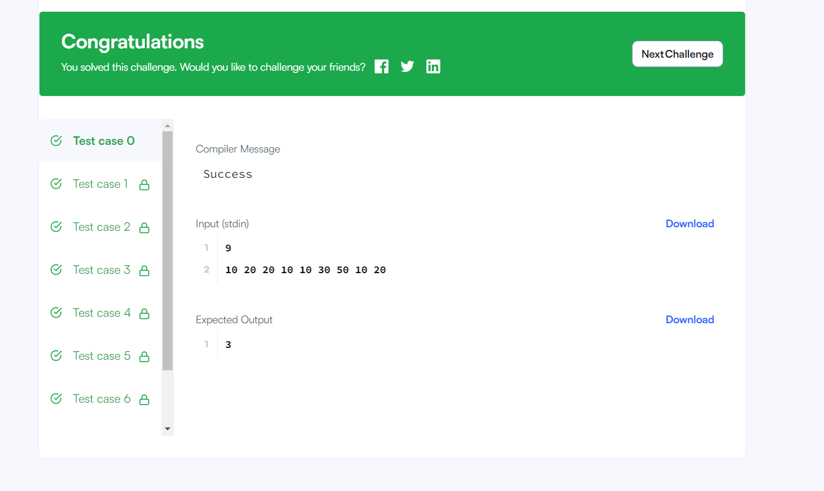

15. Sherlock and Squares

#include <bits/stdc++.h>

using namespace std;

string ltrim(const string &);

string rtrim(const string &);

vector<string> split(const string &);

/*

* Complete the 'squares' function below.

*

* The function is expected to return an INTEGER.

* The function accepts following parameters:

* 1. INTEGER a

* 2. INTEGER b

*/

int squares(int a, int b) {

int lower_bound = ceil(sqrt(double(a)));

int upper_bound = floor(sqrt(double(b)));

return upper_bound - lower_bound + 1 ;

}

int main()

{

ofstream fout(getenv("OUTPUT_PATH"));

string q_temp;

getline(cin, q_temp);

int q = stoi(ltrim(rtrim(q_temp)));

for (int q_itr = 0; q_itr < q; q_itr++) {

string first_multiple_input_temp;

getline(cin, first_multiple_input_temp);

vector<string> first_multiple_input = split(rtrim(first_multiple_input_temp));

int a = stoi(first_multiple_input[0]);

int b = stoi(first_multiple_input[1]);

int result = squares(a, b);

fout << result << "\n";

}

fout.close();

return 0;

}

string ltrim(const string &str) {

string s(str);

s.erase(

s.begin(),

find_if(s.begin(), s.end(), not1(ptr_fun<int, int>(isspace)))

);

return s;

}

string rtrim(const string &str) {

string s(str);

s.erase(

find_if(s.rbegin(), s.rend(), not1(ptr_fun<int, int>(isspace))).base(),

s.end()

);

return s;

}

vector<string> split(const string &str) {

vector<string> tokens;

string::size_type start = 0;

string::size_type end = 0;

while ((end = str.find(" ", start)) != string::npos) {

tokens.push_back(str.substr(start, end - start));

start = end + 1;

}

tokens.push_back(str.substr(start));

return tokens;

}

Output :-



17. Birthday Chocolate

#include <bits/stdc++.h>

using namespace std;

string ltrim(const string &);

string rtrim(const string &);

vector<string> split(const string &);

/*

* Complete the 'birthday' function below.

*

* The function is expected to return an INTEGER.

* The function accepts following parameters:

* 1. INTEGER_ARRAY s

* 2. INTEGER d

* 3. INTEGER m

*/

int sum(vector<int> a , int start , int end) {

int sum = 0 ;

for(int i = start ; i <= end ; i++) {

sum += a[i] ;

}

return sum ;

}

int birthday(vector<int> s, int d, int m) {

int start = 0;

int end = m -1 ;

int ans = 0 ;

while(end < s.size()) {

if(sum(s , start , end) == d) {

ans++;

}

start++;

end++;

}

return ans;

}

int main()

{

ofstream fout(getenv("OUTPUT_PATH"));

string n_temp;

getline(cin, n_temp);

int n = stoi(ltrim(rtrim(n_temp)));

string s_temp_temp;

getline(cin, s_temp_temp);

vector<string> s_temp = split(rtrim(s_temp_temp));

vector<int> s(n);

for (int i = 0; i < n; i++) {

int s_item = stoi(s_temp[i]);

s[i] = s_item;

}

string first_multiple_input_temp;

getline(cin, first_multiple_input_temp);

vector<string> first_multiple_input = split(rtrim(first_multiple_input_temp));

int d = stoi(first_multiple_input[0]);

int m = stoi(first_multiple_input[1]);

int result = birthday(s, d, m);

fout << result << "\n";

fout.close();

return 0;

}

string ltrim(const string &str) {

string s(str);

s.erase(

s.begin(),

find_if(s.begin(), s.end(), not1(ptr_fun<int, int>(isspace)))

);

return s;

}

string rtrim(const string &str) {

string s(str);

s.erase(

find_if(s.rbegin(), s.rend(), not1(ptr_fun<int, int>(isspace))).base(),

s.end()

);

return s;

}

vector<string> split(const string &str) {

vector<string> tokens;

string::size_type start = 0;

string::size_type end = 0;

while ((end = str.find(" ", start)) != string::npos) {

tokens.push_back(str.substr(start, end - start));

start = end + 1;

}

tokens.push_back(str.substr(start));

return tokens;

}

Output :-

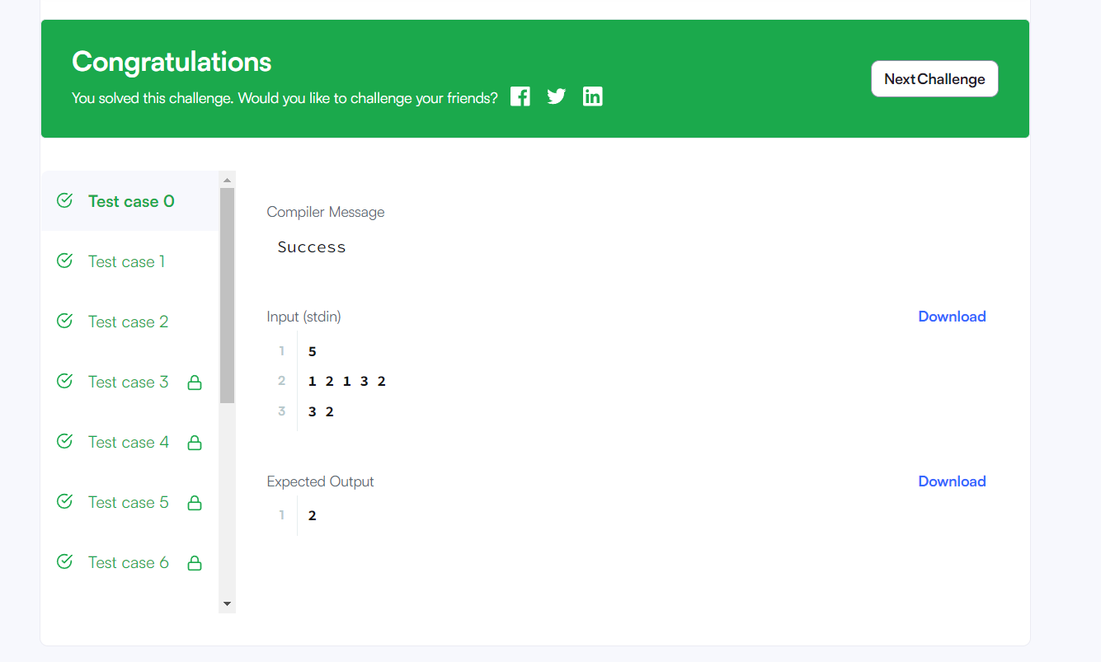

18. Utopian Tree

Code :-

#include <bits/stdc++.h>

using namespace std;

string ltrim(const string &);

string rtrim(const string &);

/*

* Complete the 'utopianTree' function below.

*

* The function is expected to return an INTEGER.

* The function accepts INTEGER n as parameter.

*/

int utopianTree(int n) {

int height = 1;

if(n==0){

return height;

}

for(int i = 1;i<=n;i++){

if((i%2)==1){

height*=2;

}else{

height+=1;

}

}

return height;

}

int main()

{

ofstream fout(getenv("OUTPUT_PATH"));

string t_temp;

getline(cin, t_temp);

int t = stoi(ltrim(rtrim(t_temp)));

for (int t_itr = 0; t_itr < t; t_itr++) {

string n_temp;

getline(cin, n_temp);

int n = stoi(ltrim(rtrim(n_temp)));

int result = utopianTree(n);

fout << result << "\n";

}

fout.close();

return 0;

}

string ltrim(const string &str) {

string s(str);

s.erase(

s.begin(),

find_if(s.begin(), s.end(), not1(ptr_fun<int, int>(isspace)))

);

return s;

}

string rtrim(const string &str) {

string s(str);

s.erase(

find_if(s.rbegin(), s.rend(), not1(ptr_fun<int, int>(isspace))).base(),

s.end()

);

return s;

}

Output :-

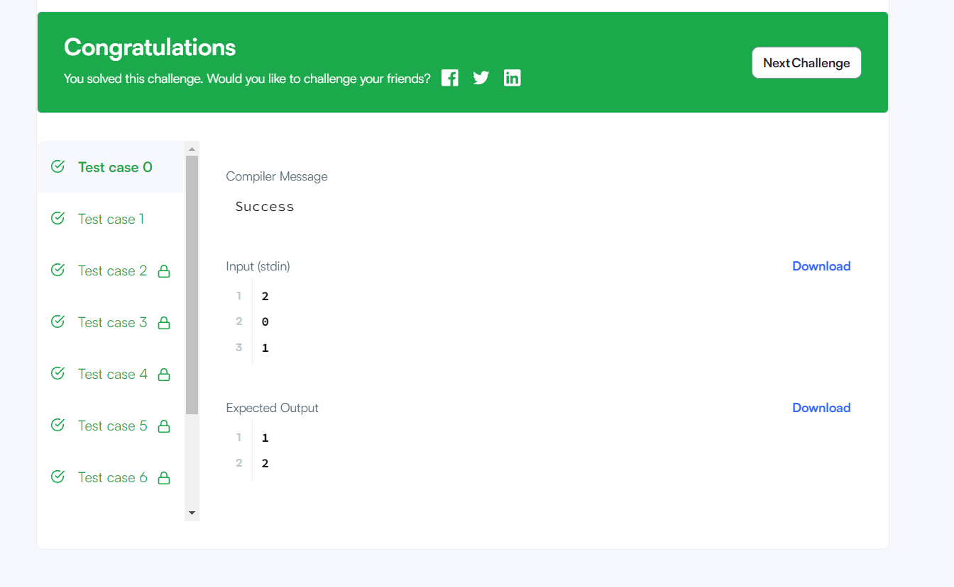

19. The Hurdle Race

Code :-

#include <bits/stdc++.h>

using namespace std;

string ltrim(const string &);

string rtrim(const string &);

vector<string> split(const string &);

/*

* Complete the 'hurdleRace' function below.

*

* The function is expected to return an INTEGER.

* The function accepts following parameters:

* 1. INTEGER k

* 2. INTEGER_ARRAY height

*/

int hurdleRace(int k, vector<int> a) {

return *max_element(a.begin() , a.end()) > k ? *max_element(a.begin() , a.end()) - k : 0 ;

}

int main()

{

ofstream fout(getenv("OUTPUT_PATH"));

string first_multiple_input_temp;

getline(cin, first_multiple_input_temp);

vector<string> first_multiple_input = split(rtrim(first_multiple_input_temp));

int n = stoi(first_multiple_input[0]);

int k = stoi(first_multiple_input[1]);

string height_temp_temp;

getline(cin, height_temp_temp);

vector<string> height_temp = split(rtrim(height_temp_temp));

vector<int> height(n);

for (int i = 0; i < n; i++) {

int height_item = stoi(height_temp[i]);

height[i] = height_item;

}

int result = hurdleRace(k, height);

fout << result << "\n";

fout.close();

return 0;

}

string ltrim(const string &str) {

string s(str);

s.erase(

s.begin(),

find_if(s.begin(), s.end(), not1(ptr_fun<int, int>(isspace)))

);

return s;

}

string rtrim(const string &str) {

string s(str);

s.erase(

find_if(s.rbegin(), s.rend(), not1(ptr_fun<int, int>(isspace))).base(),

s.end()

);

return s;

}

vector<string> split(const string &str) {

vector<string> tokens;

string::size_type start = 0;

string::size_type end = 0;

while ((end = str.find(" ", start)) != string::npos) {

tokens.push_back(str.substr(start, end - start));

start = end + 1;

}

tokens.push_back(str.substr(start));

return tokens;

}

Output :-



21. Angry Professor

Code :-

#include <bits/stdc++.h>

using namespace std;

string ltrim(const string &);

string rtrim(const string &);

vector<string> split(const string &);

/*

* Complete the 'angryProfessor' function below.

*

* The function is expected to return a STRING.

* The function accepts following parameters:

* 1. INTEGER k

* 2. INTEGER_ARRAY a

*/

string angryProfessor(int k, vector<int> a) {

int present = 0 ;

for(int& stud : a) {

if(stud <= 0) {

present++;

}

}

return present >= k ? "NO" : "YES" ;

}

int main()

{

ofstream fout(getenv("OUTPUT_PATH"));

string t_temp;

getline(cin, t_temp);

int t = stoi(ltrim(rtrim(t_temp)));

for (int t_itr = 0; t_itr < t; t_itr++) {

string first_multiple_input_temp;

getline(cin, first_multiple_input_temp);

vector<string> first_multiple_input = split(rtrim(first_multiple_input_temp));

int n = stoi(first_multiple_input[0]);

int k = stoi(first_multiple_input[1]);

string a_temp_temp;

getline(cin, a_temp_temp);

vector<string> a_temp = split(rtrim(a_temp_temp));

vector<int> a(n);

for (int i = 0; i < n; i++) {

int a_item = stoi(a_temp[i]);

a[i] = a_item;

}

string result = angryProfessor(k, a);

fout << result << "\n";

}

fout.close();

return 0;

}

string ltrim(const string &str) {

string s(str);

s.erase(

s.begin(),

find_if(s.begin(), s.end(), not1(ptr_fun<int, int>(isspace)))

);

return s;

}

string rtrim(const string &str) {

string s(str);

s.erase(

find_if(s.rbegin(), s.rend(), not1(ptr_fun<int, int>(isspace))).base(),

s.end()

);

return s;

}

vector<string> split(const string &str) {

vector<string> tokens;

string::size_type start = 0;

string::size_type end = 0;

while ((end = str.find(" ", start)) != string::npos) {

tokens.push_back(str.substr(start, end - start));

start = end + 1;

}

tokens.push_back(str.substr(start));

return tokens;

}

Output :-

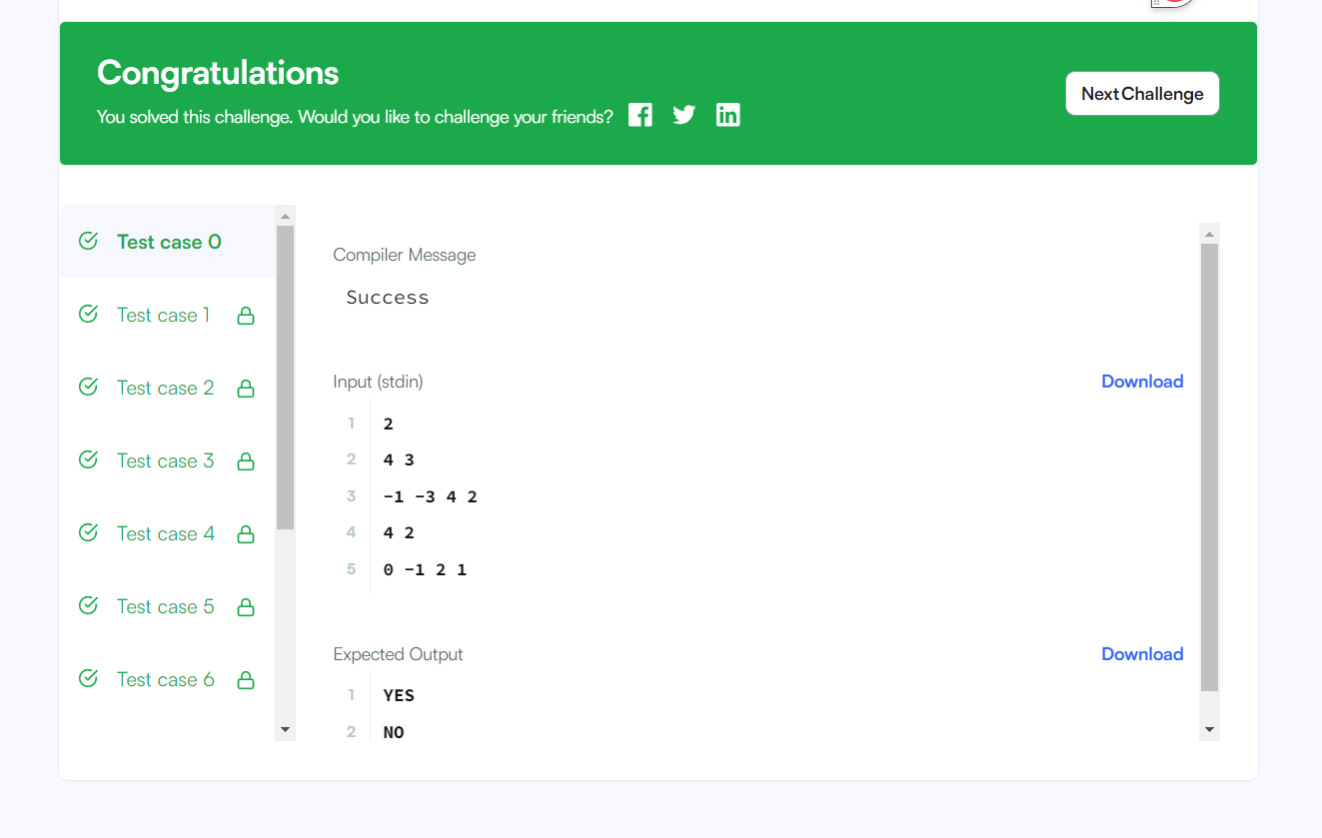

23. Beautiful Days at the Movies

Code :-

#include <bits/stdc++.h>

using namespace std;

string ltrim(const string &);

string rtrim(const string &);

vector<string> split(const string &);

/*

* Complete the 'beautifulDays' function below.

*

* The function is expected to return an INTEGER.

* The function accepts following parameters:

* 1. INTEGER i

* 2. INTEGER j

* 3. INTEGER k

*/

int reverse(int num) {

int reverse_int = 0 ;

while(num > 0) {

reverse_int = reverse_int*10 + num % 10 ;

num /= 10 ;

}

return reverse_int ;

}

int beautifulDays(int i, int j, int k) {

int beautifulDays = 0 ;

for(int days = i ; days <= j ; days++) {

int reverse_day = reverse(days) ;

if(abs(reverse_day - days) % k == 0) {

beautifulDays++;

}

}

return beautifulDays;

}

int main()

{

ofstream fout(getenv("OUTPUT_PATH"));

string first_multiple_input_temp;

getline(cin, first_multiple_input_temp);

vector<string> first_multiple_input = split(rtrim(first_multiple_input_temp));

int i = stoi(first_multiple_input[0]);

int j = stoi(first_multiple_input[1]);

int k = stoi(first_multiple_input[2]);

int result = beautifulDays(i, j, k);

fout << result << "\n";

fout.close();

return 0;

}

string ltrim(const string &str) {

string s(str);

s.erase(

s.begin(),

find_if(s.begin(), s.end(), not1(ptr_fun<int, int>(isspace)))

);

return s;

}

string rtrim(const string &str) {

string s(str);

s.erase(

find_if(s.rbegin(), s.rend(), not1(ptr_fun<int, int>(isspace))).base(),

s.end()

);

return s;

}

vector<string> split(const string &str) {

vector<string> tokens;

string::size_type start = 0;

string::size_type end = 0;

while ((end = str.find(" ", start)) != string::npos) {

tokens.push_back(str.substr(start, end - start));

start = end + 1;

}

tokens.push_back(str.substr(start));

return tokens;

}

Output :-



25. Bon Appétit

27. Cats and Mouse

#include <bits/stdc++.h>

using namespace std;

vector<string> split_string(string);

// Complete the catAndMouse function below.

string catAndMouse(int x, int y, int z) {

if(abs(x-z) == abs(y-z)) {

return "Mouse C" ;

}

else if(abs(x-z) > abs(y-z)) {

return "Cat B";

}

else {

return "Cat A" ;

}

}

int main()

{

ofstream fout(getenv("OUTPUT_PATH"));

int q;

cin >> q;

cin.ignore(numeric_limits<streamsize>::max(), '\n');

for (int q_itr = 0; q_itr < q; q_itr++) {

string xyz_temp;

getline(cin, xyz_temp);

vector<string> xyz = split_string(xyz_temp);

int x = stoi(xyz[0]);

int y = stoi(xyz[1]);

int z = stoi(xyz[2]);

string result = catAndMouse(x, y, z);

fout << result << "\n";

}

fout.close();

return 0;

}

vector<string> split_string(string input_string) {

string::iterator new_end = unique(input_string.begin(), input_string.end(), [] (const char &x, const char &y) {

return x == y and x == ' ';

});

input_string.erase(new_end, input_string.end());

while (input_string[input_string.length() - 1] == ' ') {

input_string.pop_back();

}

vector<string> splits;

char delimiter = ' ';

size_t i = 0;

size_t pos = input_string.find(delimiter);

while (pos != string::npos) {

splits.push_back(input_string.substr(i, pos - i));

i = pos + 1;

pos = input_string.find(delimiter, i);

}

splits.push_back(input_string.substr(i, min(pos, input_string.length()) - i + 1));

return splits;

}

Output :-

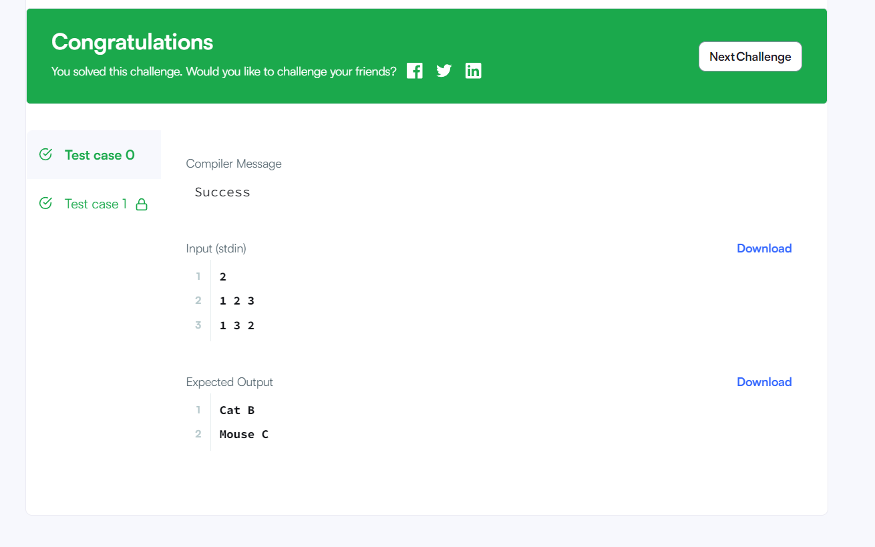

29. Circular Array Rotation

#include <bits/stdc++.h>

using namespace std;

string ltrim(const string &);

string rtrim(const string &);

vector<string> split(const string &);

/*

* Complete the 'circularArrayRotation' function below.

*

* The function is expected to return an INTEGER_ARRAY.

* The function accepts following parameters:

* 1. INTEGER_ARRAY a

* 2. INTEGER k

* 3. INTEGER_ARRAY queries

*/

vector<int> circularArrayRotation(vector<int> a, int k, vector<int> queries) {

vector<int> newArray(a.size()), result;

for(int i = 0; i < a.size(); i++){

newArray[(i + k) % a.size()] = a[i];

}

for(int i = 0; i < queries.size(); i++) result.push_back(newArray[queries[i]]);

return result;

}

int main()

{

ofstream fout(getenv("OUTPUT_PATH"));

string first_multiple_input_temp;

getline(cin, first_multiple_input_temp);

vector<string> first_multiple_input = split(rtrim(first_multiple_input_temp));

int n = stoi(first_multiple_input[0]);

int k = stoi(first_multiple_input[1]);

int q = stoi(first_multiple_input[2]);

string a_temp_temp;

getline(cin, a_temp_temp);

vector<string> a_temp = split(rtrim(a_temp_temp));

vector<int> a(n);

for (int i = 0; i < n; i++) {

int a_item = stoi(a_temp[i]);

a[i] = a_item;

}

vector<int> queries(q);

for (int i = 0; i < q; i++) {

string queries_item_temp;

getline(cin, queries_item_temp);

int queries_item = stoi(ltrim(rtrim(queries_item_temp)));

queries[i] = queries_item;

}

vector<int> result = circularArrayRotation(a, k, queries);

for (size_t i = 0; i < result.size(); i++) {

fout << result[i];

if (i != result.size() - 1) {

fout << "\n";

}

}

fout << "\n";

fout.close();

return 0;

}

string ltrim(const string &str) {

string s(str);

s.erase(

s.begin(),

find_if(s.begin(), s.end(), not1(ptr_fun<int, int>(isspace)))

);

return s;

}

string rtrim(const string &str) {

string s(str);

s.erase(

find_if(s.rbegin(), s.rend(), not1(ptr_fun<int, int>(isspace))).base(),

s.end()

);

return s;

}

vector<string> split(const string &str) {

vector<string> tokens;

string::size_type start = 0;

string::size_type end = 0;

while ((end = str.find(" ", start)) != string::npos) {

tokens.push_back(str.substr(start, end - start));

start = end + 1;

}

tokens.push_back(str.substr(start));

return tokens;

}

Output :-

